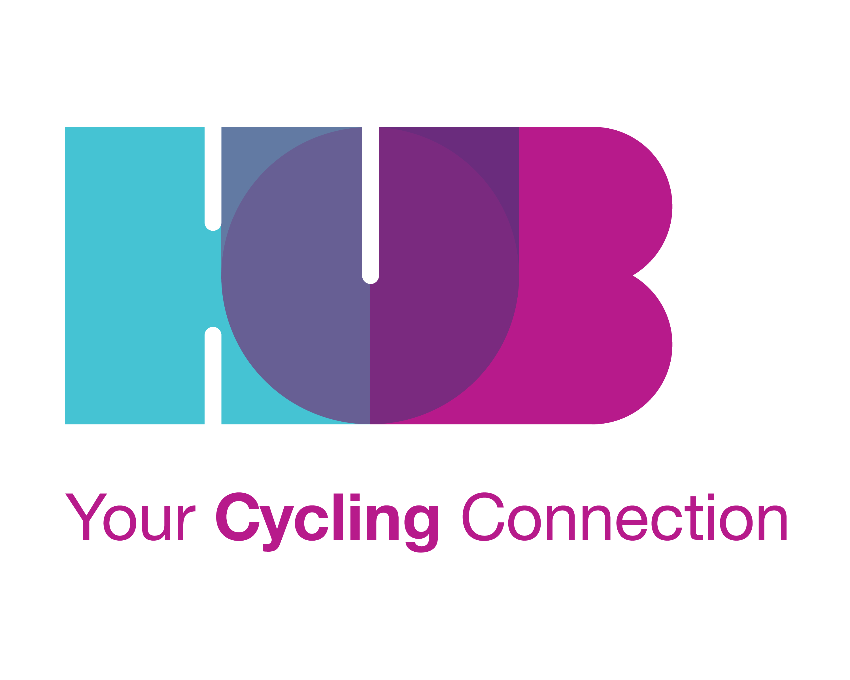
HUB CYCLING BOARD MEMBER APPLICATION FORM
HUB’s Board Development Committee will prepare a summary of each candidate to distribute and post on our website prior to the AGM, based on information provided in this application. The Committee may also identify recommended candidates based on the skills sought.

BOARD CANDIDATE INFORMATION
NAME:
ADDRESS:
CITY and POSTAL CODE:
TELEPHONE:
EMAIL:
OCCUPATION:

HUB MEMBER: (Yes/No):

PREVIOUS VOLUNTEER BOARD EXPERIENCE: (Yes/No):

OTHER BOARD EXPERIENCE? (CORPORATE, ETC): (Yes/No):

1.History of Board experience and other volunteer work (Please briefly list dates and responsibilities).

2. Please list 2 examples of specific contributions you’ve made while serving on a previous Board / Committee / Team in a volunteer setting. Contributions from a professional setting could also be included, though volunteer examples may be more relevant.

3. History of employment or other interests (Please briefly list dates and responsibilities).

4. In 50 words or less, what is your vision for cycling in Metro Vancouver, or how do you feel about cycling for transportation? HUB may include this on our website and hand out to members at the AGM prior to the election.

5. From the list of 2019 Board needs, what skills and/or experience would you bring to the Board? Feel free to describe other relevant skills that would be of assistance to the position (Between 40-150 words).

6. How do you feel about committing minimum of 10 hours per month to a Board Director position?

7. How many hours per month can you commit in a Board Director role?

8. Do you anticipate any problem with committing to the full 2-year term?

9. Please include a short bio (75-100 words) that HUB may include on our website and hand out to members at the AGM prior to the election.

Pre-Election Candidate Orientation
An in-person meeting with candidates, or a group orientation session, may be held to further describe the position, answer questions, and assist the Board and the candidate with assessment of fit between the candidate and a HUB Cycling Director role. The Board Development Committee will set this up after applications have been received. Orientation Resources: Board Reference Manual, website www.bikehub.ca, and current Board Directors.

CANDIDATE INTENTION
If selected, please allow my name to stand for nomination to the HUB Board of Directors. I have read the above information and am willing to commit my time to HUB Cycling.

Type Name as Signature |  | Date

* Only HUB Cycling Members are eligible for Board positions. If a candidate is not yet a HUB member, online Membership payment is available at bikehub.ca/join or the Membership Form may be downloaded and submitted with payment anytime before taking office, including in person at the Annual General Meeting.

Thank-you for your interest in applying for the HUB Board of Directors. We appreciate your engagement! We would like to welcome you, and encourage you to take an active role in the organization, whether as a Director, volunteer or supporter. There are many effective ways to become involved with your time as a member or volunteer. If you have some of these skills but are not able to commit to the position of Board director, we would love to chat with you about other ways to share your skills with us. You can contact HUB Cycling by emailing volunteer@bikehub.ca

Donations and financial support is always welcome and put to effective use. Donations are eligible for charitable tax credits: bikehub.ca/donate

The Board Director Election will be held at the Annual General Meeting on September 14, 2019. More information about the election will be provided via email and at the Pre-Election Orientation meetings. See www.bikehub.ca for AGM details.

